**AWS Task-5**

**Task Description:**

Deploy a simple web application using AWS code commit, code build and deploy & access via browser and automate via code pipeline.

========================================================

**Steps**: -

1. **Launching EC2 instance**

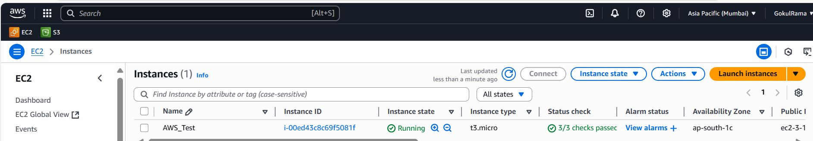

1. **Assign an IAM Role with the AmazonEC2RoleforAWSCodeDeploy policy.**

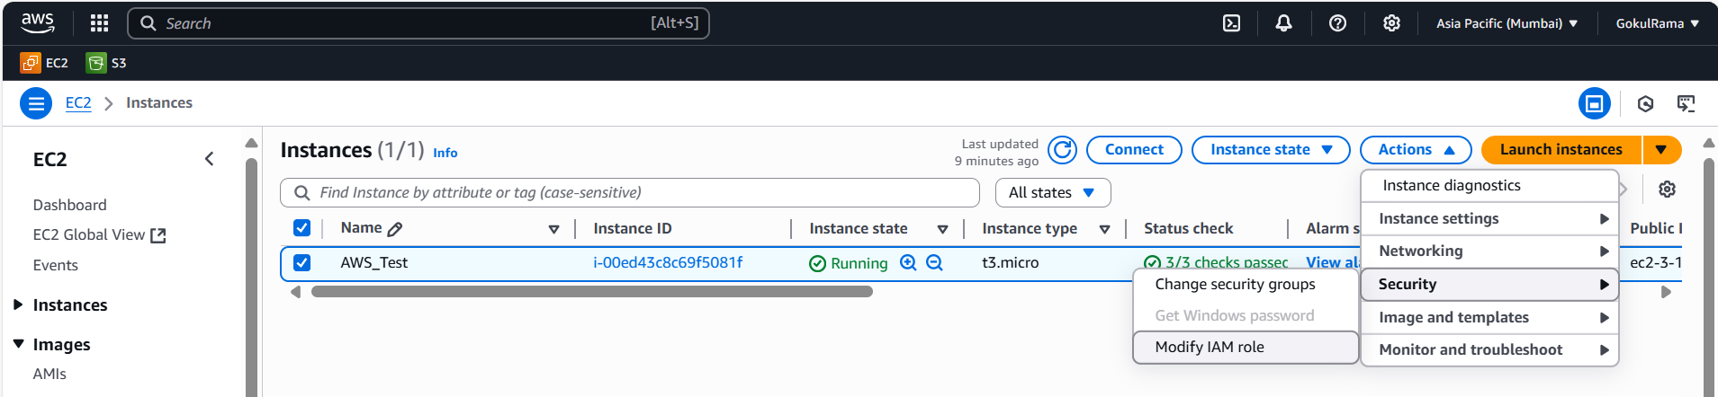

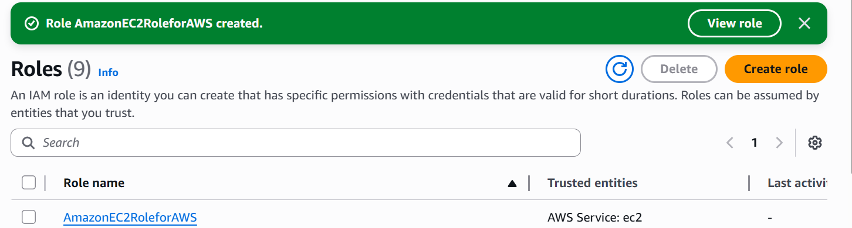

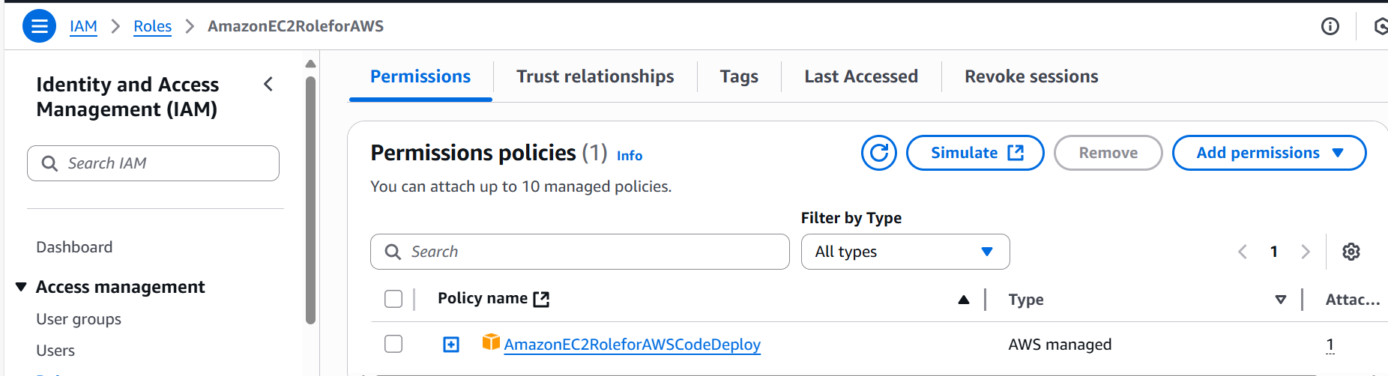

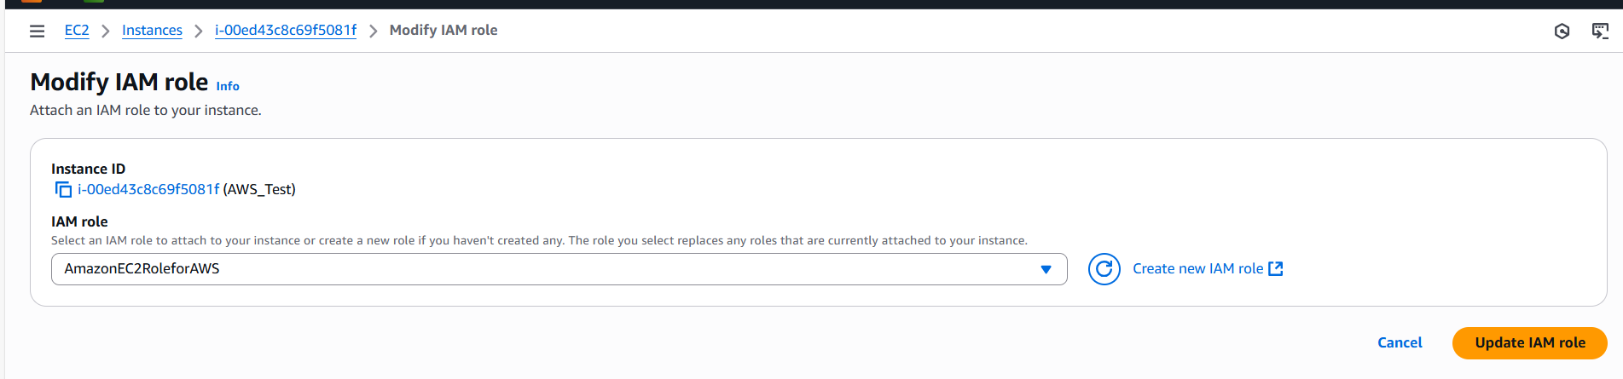

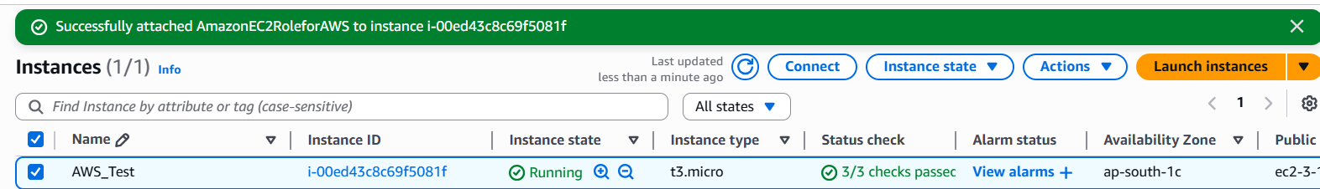

1. **Install code deploy agent in EC2**

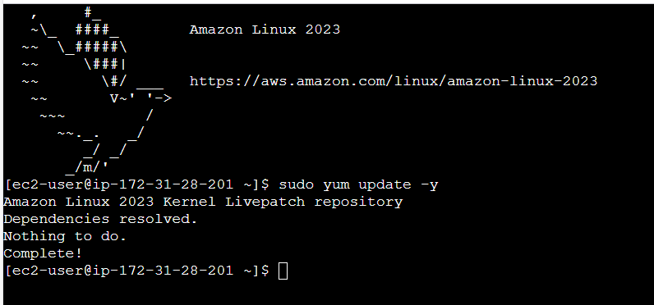

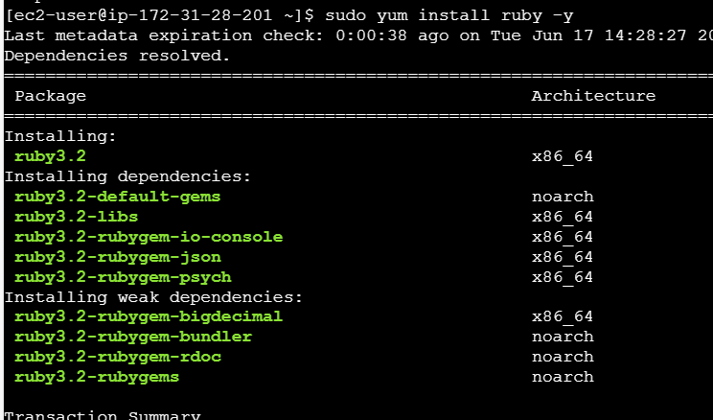

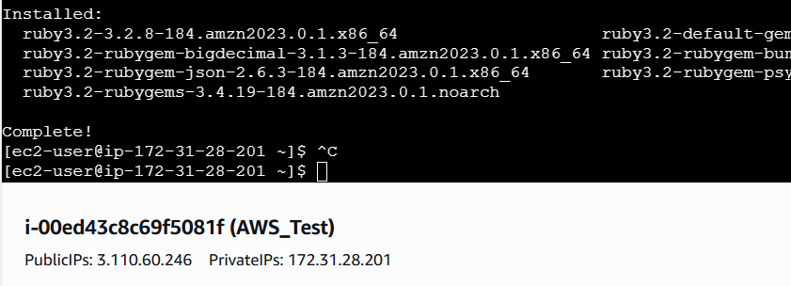

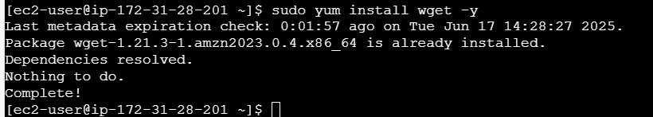

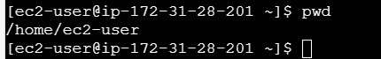

**wget https://aws-codedeploy-ap-south-1.s3.amazonaws.com/latest/install**

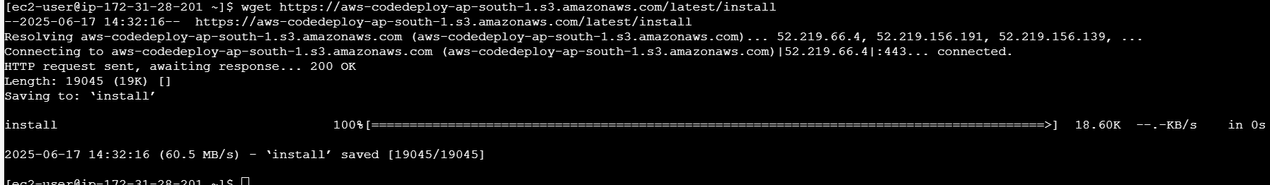

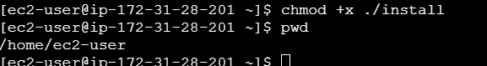

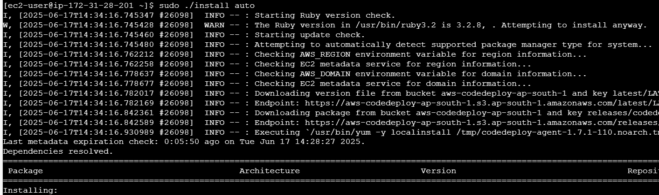

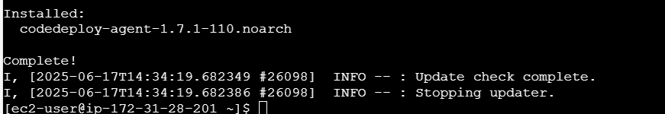



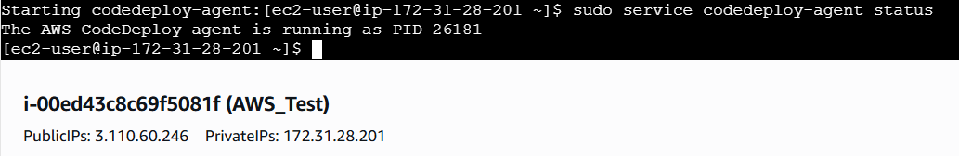

1. **Create an Application in Code Deploy**

